|  |  |  |  |  |
| --- | --- | --- | --- | --- |
|  | | | | |
| **SPECIFICATION FOR APPROVAL** | | | | |
| Customer |  | | | |
| Part No.： | GA6-868 | | | |
| **Company：** | Shenzhen Hurryup Technology Co., Ltd. | | | |
| **Part No.：** | GA6-RG174 | | | |
| **Product Name：** | 868mhz Sucker Antenna with 3 meters RG174 Cable and SMA Connector | | | |
| 1. Newly Approved 2. Material Approved 3. Material Approved | | | | |
| VERSION | DATE | PREPARED BY | CHECKED | APPROVED |
| V01 |  |  |  |  |
| Hurryup Approval（Signature） | | | | |
| Customer Approval（Signature） | | | | |

# 产品技术指标(PRODUCT TECHNICAL SPECIFICATION)

电性能指标Electrical Specifications

|  |  |
| --- | --- |
| 频率范围Frequency Range (MHz) | 868 |
| 输入阻抗Input Impedance (Ω) | 50 |
| 电压驻波比V.S.W.R | ≤1.5 |
| 增益Gain (dBi) | 3 |
| 极化形式Polarization | 垂直极化Vertical |
| 辐射方向Radiation Direction | 全向Omnidirectional |
| 最大输入功率Max Input Power (w) | 50 |
| 机械指标Mechanical Specifications | |
| 天线长度Antenna Height (mm) | 2000 |
| 底部直径Base Diameter(mm) | 300 |
| 电缆长度Cable (mm) | 3000(customized) |
| 连接器型号Connect Type | SMA male (customized) |
| 固定方式Mounting | 磁性Magnetic Base |
| 外壳颜色 Color | 黑色Black |
| 电缆Cable | RG174 |
| 吸力Suction（KG） | 1.0 |
| 接头Attachment | 焊接Welding |

1. 产品图片Product Image

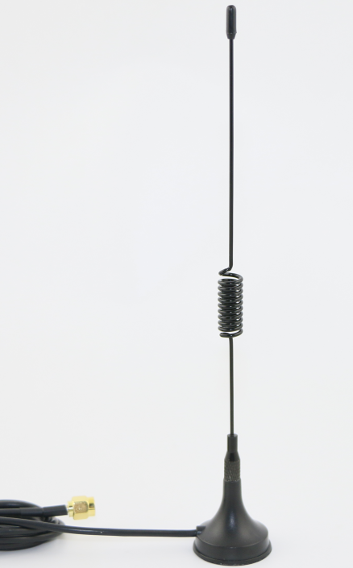

3.产品规格图(PRODUCT SPECIFICATION CHART)

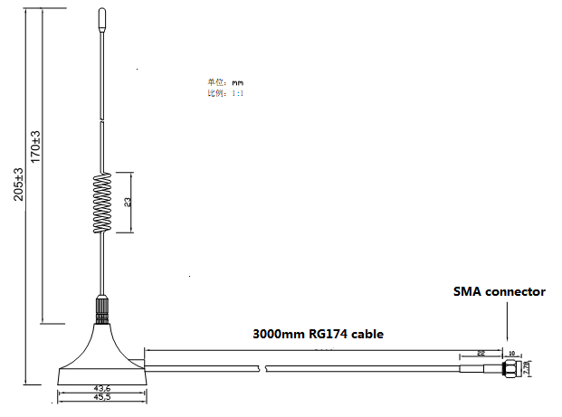

1. 驻波图（STATIONARY WAVE PATTERN）
2. 